Exp:7-Determination and plotting of Capacitance of isolated and concentric sphere with different inner and outer radius and dielectric constant of the dielectric mediums.

Aim:
To write program for Capacitance of an isolated sphere and two concentric sphere using SCILAB.

Software required:
- SCILAB version 6.0.1

Theory: Program:
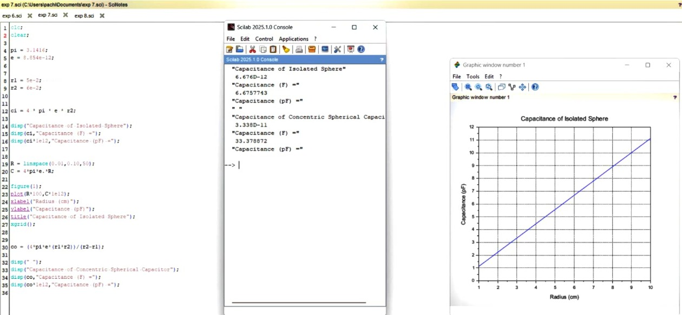
Calculation

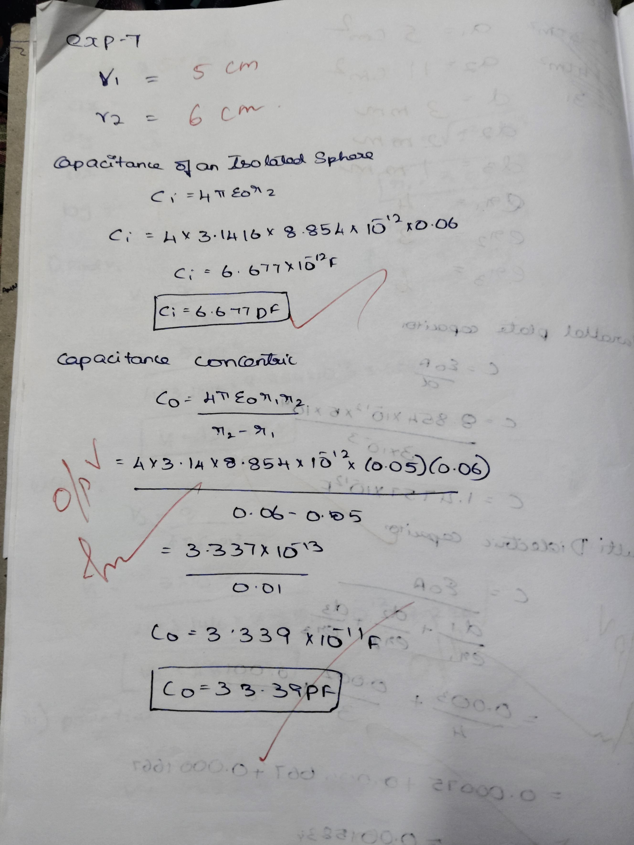

CASE 1:-CONCENTRIC SPHERICAL CAPACITOR WITH DIFFERENT DIELECTRIC MEDIUMS CODE:-

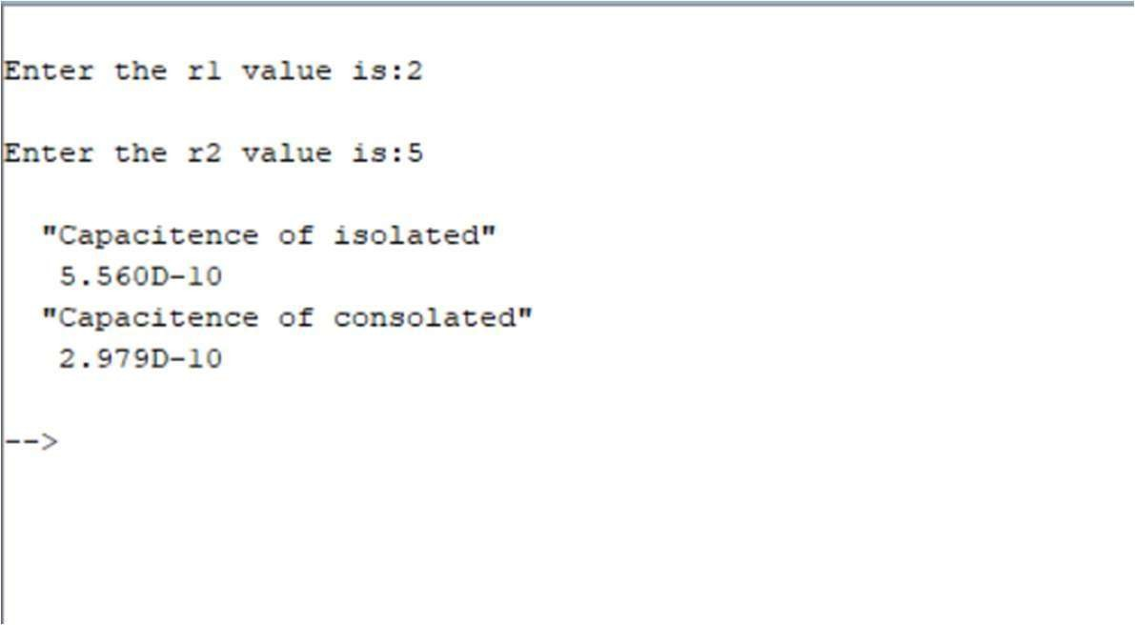

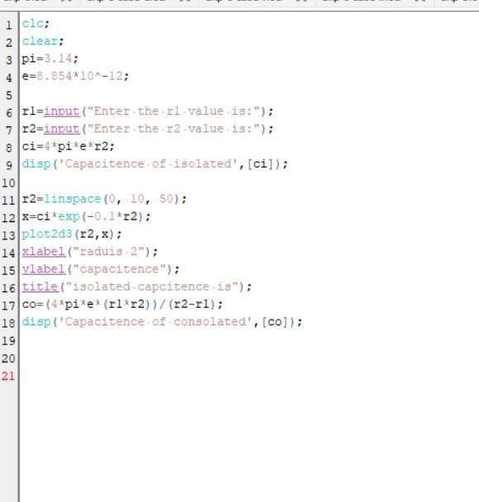
Output:
CASE 2: ISOLATED SPHERE CODE:-

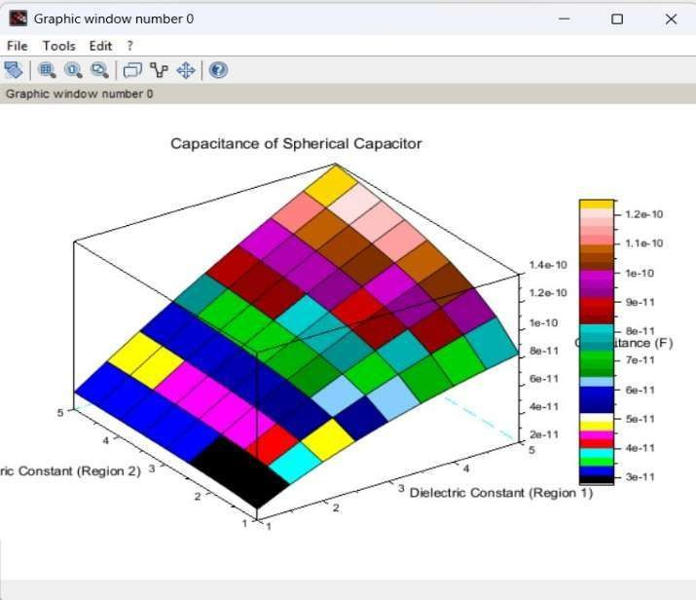

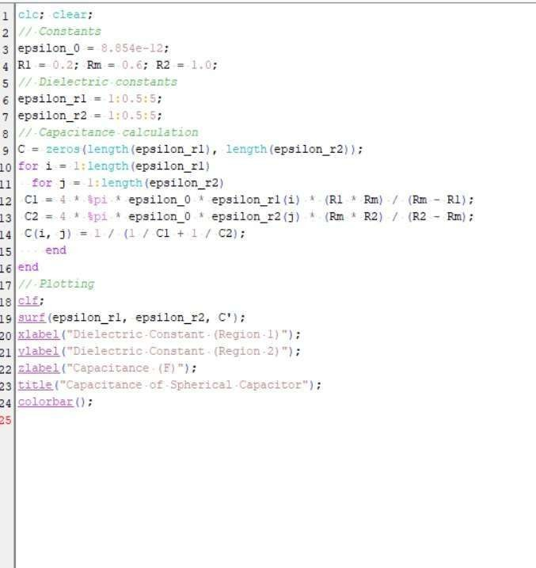
Output:
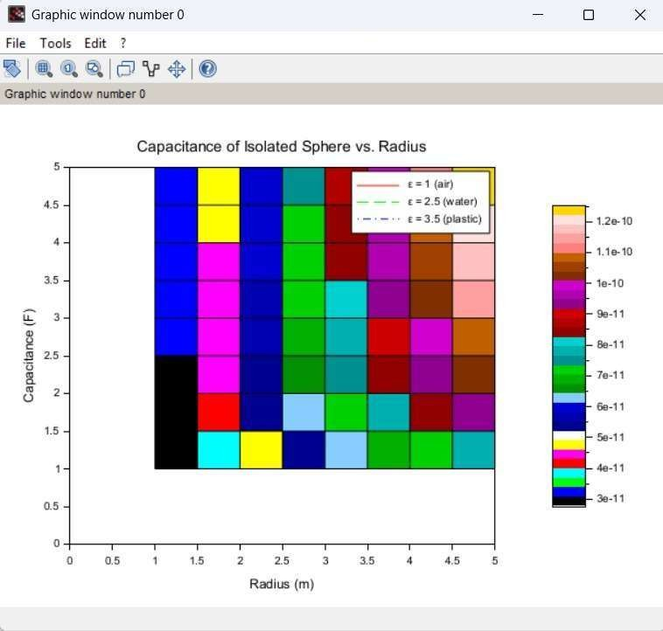

CASE 3: CONCENTRIC SPHERICAL CAPACITOR CODE:

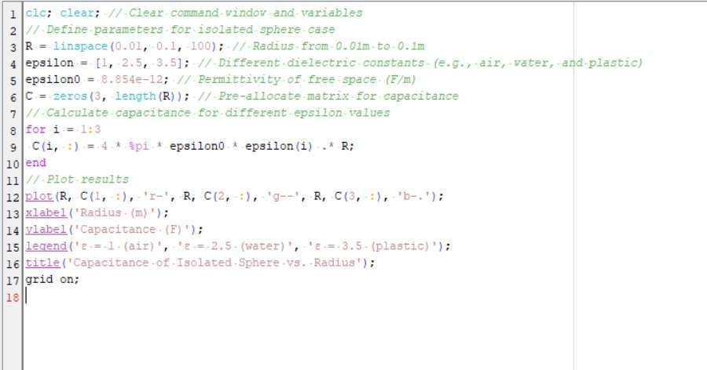
Output:
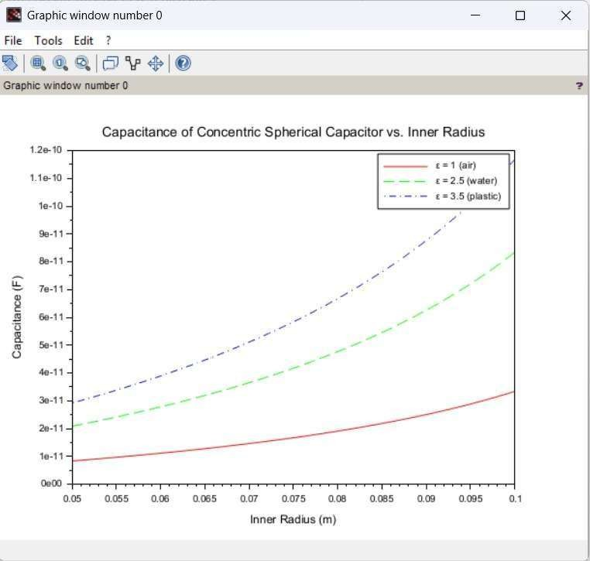

Result :
Thus the program was verified for Capacitance of an isolated sphere and two concentric sphere using SCILAB was successfully.

